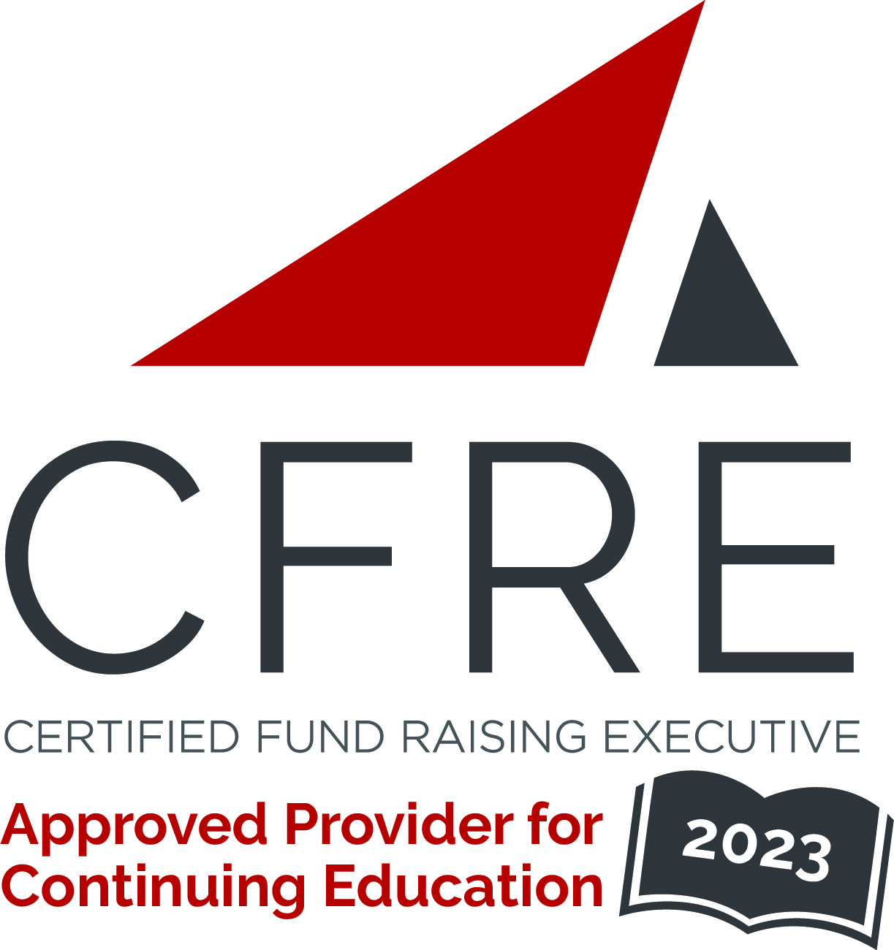  CFRE International has developed this form as a way for you to quickly track (and keep in your files!) the continuing education sessions you have attended. Simply check the boxes next to the sessions you attended. At the end of the conference, add up the total number of hours. Keep this sheet and you will be ready to complete your application form. All of the session slots listed are eligible for continuing education points on your CFRE application for initial certification and/or recertification. Sessions not listed here are not eligible for points. |  | CONTINUING EDUCATION POINTS TRACKER

Activity Organizer: - Northeast Annual Giving Conference, LLC
Title of Activity: - Northeast Annual Giving Conference 2023
Names of Presenter(s): - Various
Dates and Location: - March 27-29, 2023 – Baltimore, MD USA

Date: 27 March, 2023
Session 2: 2:00pm – 4:00pm (2 pts)
- An Introduction to Annual Giving and the Northeast Annual Giving Conference

Date: 28 March, 2023
Session 3: 11:00am – 12:00pm (1 pt)
- A Love Connection: Annual Giving & Engagement within an Advancement Model
- Direct Mail: Tips, Tricks, and Tactics
- Great Giving Days: A Forum

Date: 28 March, 2023
Session 4: 1:30pm – 2:30pm (1 pt)
- Let’s Talk About Digital Gift Officers
- Volunteer Management Across the Decades
- Lunching a Donor Engagement Center at GWU

Date: 28 March, 2023
Session 5: 3:00pm – 4:00pm (1 pt)
- Topping Off the Pyramid
- Fundraising BS
- The Spaghetti Method

Date: 28 March, 2023
Session 6: 4:15pm – 5:15pm (1 pt)
- Cause-Based Crowdfunding: A Crowdfunding System to Educate & Inspire
- Anatomy of a Digital End-of-Year Campaign
- Transforming Your Annual Giving Process

Date: 29 March, 2023
Session 7: 9:00am – 10:00am (1 pt)
- Don’t Corner Yourself
- How To Talk Good

Date: 29 March, 2023
Session 8: 10:30am – 11:30am (1 pt)
- Building the Future Donor Pipeline
- Direct Mail – Donor’s Perspective
- Phonathons and Engagement Centers

Date: 29 March, 2023
Session 7: 12:00pm – 1:00pm (1 pt)
- The Recurring Riddle of Regular Giving
- Best Job on Campus
- Give Now, Pay Later

Total number of points attained: ________

